
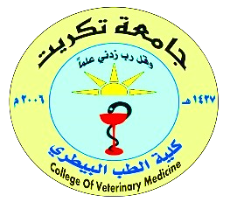


Tikrit University
College of Veterinary Medicine
Subject name:
Subject year:
Lecturer name:
Academic Email:
Font (20)
Font type (times new roman)

Lecture Title
Font (28)
Font type (pt bold heading)


Tikrit University- College of Veterinary Medicine
Email: cvet.tu.edu.iq

Lecturers link
2024-2025

